Tweening a Shape
Objective: Turn one raw shape into another shape. The shape must be in an editable form, not a symbol.
- To create a new project go to ‘Create New’
- Select a color for the fill. Make the stroke color black.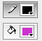
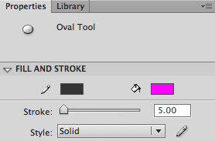
- Increase the with of the stroke. Use the black arrow to select the back outline of the circle. In the Properties menu make the stroke 5.
- Use the circle tool to draw one circle in keyframe 1.
- Go to frame 36 and create a new blank Keyframe by pressing [ F7 ].
- Change the fill color. Draw a new shape in frame 36.
- Click somewhere between keyframe one and 36. Go to [ Insert ] [ Shape Tween ] 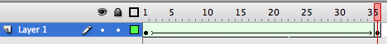
- SAVE using the media arts formula. Example: JLDoe_8A_TweenShape

