Drawing
*Objective: Turn an existing photograph into a drawing.

- Save a photograph to your folder on the desk top.
- Lauch Adobe Phototshope CS3. 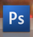
- Go to [File] (open) and locate your photograph.
- RESIZE your image by going to [Image] (image size) See example: 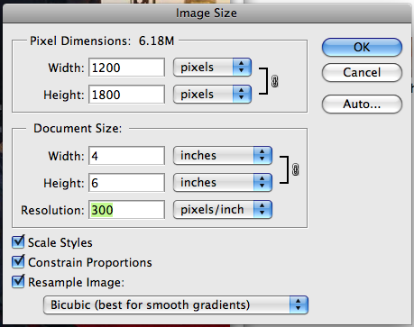
Only change “Document Size” not “Pixel Dimension”
- Create a new layer, think of it as tracing paper go to
[Layer] (new) [Layer…] Re-name the layer “Draw!!!”
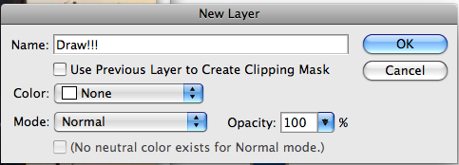
- Change the foregroung color black 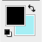
- Select the pencil tool and change the brush size from 1 to 9 px
Stay on the “Draw!!!” layer as outline every detail.
- Fill in spaces with color using the paint bucket tool
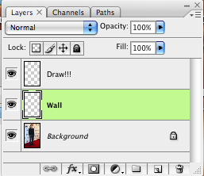
- Create a new Layer,
[Layer] (new) [Layer…] Re-name the layer “Wall”
move the “Wall” layer under the drawing layer
- Select a new foreground color and a new background color 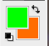
Use the gradiant tool, (sometimes hidden under the paint bucket) to fill the wall behind the drawing with a blend of two colors choose a color at the top bar 