Cutting Out Objects

- Save a picture of a whole object to your folder located on the desktop.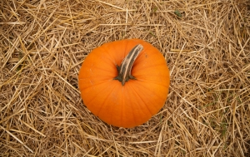

- Launch Adobe Photoshop CS6 ; Open the image when you are in Photoshop.

- Adjust your Windows so that you can see both the Layers Window and the History Window.

- Make the Background layer a workable layer by going to [Layer] (new) [Layer from Background]

- Make another plain layer by hitting the new layer option at the bottom of the layers window. 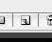
- Move [Layer 1] under [Layer 0] 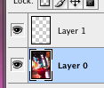 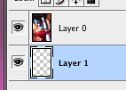

- Make sure you are on [Layer 0]. It should be highlighted blue.

- Use the polygonal lasso tool * Make many points by clicking on the mouse. Hit [return] key to closes the shape. ‘Marching Ants’ should appear around selected area.
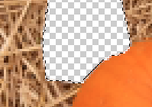
- Press (delete) you should see the gray & white checkerboard.
*Cut out smaller chunks of the background, do not attempt to cut out
the entire object at once.

- To deselect, (make the ‘marching ants’ go away,) [ command ] + [ D ]
- After you have cut away the background that is touching the object, use your eraser to remove the left over background. NEVER use the eraser close to the object.
- Save using the media arts formula, example
JLDoe_7B_pumpkin.psd

Tips
• You should zoom in to work on your project, use the zoom tool
• [ apple ] + [ + ] = zoom in
• [ apple ] + [ - ] = zoom out

