Bouncing Ball
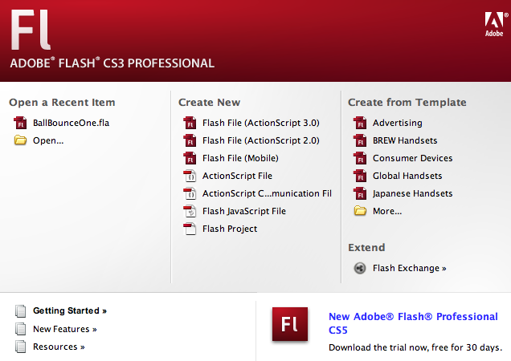
- To create a new project go to ‘Create New’
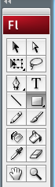
- Select the Oval 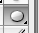tool from your tool bar, it is a ‘Shape Tool’ so it may
be hidden under other shapes, such as a rectangle.

- Select a color for your ball
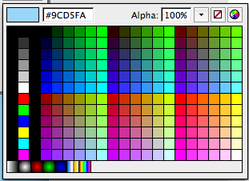
•Make sure you write down the
color number incase you have to
leave your project and work on it
another day.

          - •Example 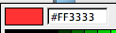

(4) Click on your stage and drag out one ball.
• you only want one ball per frame
• 12 frames = one second

(5) Turn on your ‘Onion Skin’. This allows you to see multiple frames at the same time. The current frame will appear in its full bright color. All the previous frames will appear faded.
(6) Insert a new ‘Blank Keyframe’ by pressing [ F7 ]
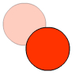
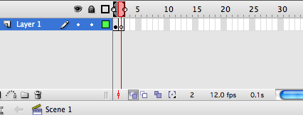
(7) Draw a new ball in the new keyframe. This ball should slightly
overlap the previous ball.
(8) Continue steps 6 and 7
(9) SAVE using the media arts formula. Example: JLDoe_8A_Ball1
TROUBLE SHOOTING
- To watch your movie, press [Return] on the keyboard. Or {Control} ‘Test Movie’
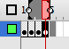
- To move the ball use the black arrow. Select both the ball and the ball’s outline by using the [Shift] key. Move the existing ball to its appropriate location.
- You can delete an entire key frame by pressing on the
keyframe and holding the mouse down for a few second.
A new menu will appear. Select ‘Remove Frames’
- To Un-Do press [command] + [ Z ]
- If you want a perfect circle, not an oval, hold down the [Shift] key as you pull out your circle.
