If I Could Go Anywhere….
Part two, Location

Requirements for Location Photograph;
• Full color photographs
• Place you have never been to before
• Include a ground that you can stand on
(1) Launch FireFox
(2) Go to the Following web site: www.gettimages.com

(3) Click on tab titled “Images” choose ‘Creative’ and then ‘All creative’
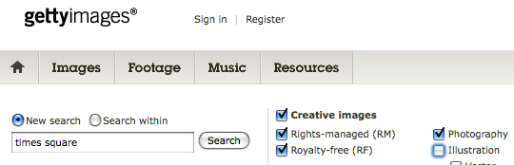

(4) Review requirements above and select a photograph.
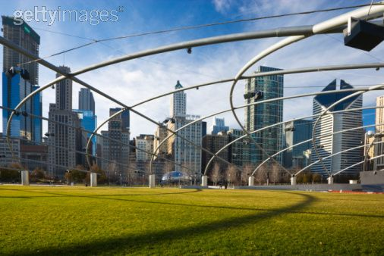
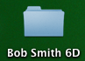
(5) Double click on thumbnail picture. A second Internet window should appear with a larger version of the same photograph. Drag that image to your folder on the desktop.

(6) Cite image with citation machine and save information to a word document.

(7) Quit FireFox, Launch Adobe Photoshop CS3 and open picture

(8) Resize image using cop tool, Change dimensons at top bar

(9) Save using media arts formula
example: JLDoe_6B_TimesSq

